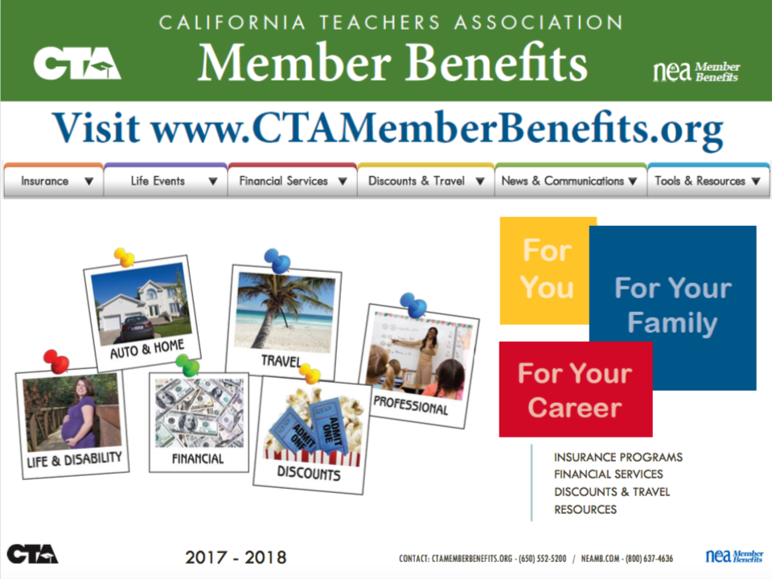

Campbell Hi School Teachers Association (CHSTA) is hosting a CTA Member Benefits presentation on Monday, April 16.

- Address-CTA San Jose RRC, 4810 Harwood Drive, Suite #100, San Jose, CA 95124

- Time-3:30 to 5:00 p.m.

- Presentation- CTA/NEA Member Benefits for You, Your Family, and Your Career
Learn about your numerous exclusive Member Benefits, just one of the advantages of your association membership. Member Benefits staff will provide an overview of almost 50 different programs designed for members to save you and your family time and money, and also help with your finances, insurance protection, professional development and retirement planning. Join the thousands of members enjoying the value of Member Benefits every day!

- RSVP to Liz Tanner by 4/9: liztannerCHSTA@gmail.com.

